# Task D: Procedures

## 1. **`sp_apply_category_discount(p_category TEXT, p_percent NUMERIC)`**     - Reduce `unit_price` of **active** products in a category by `p_percent` (e.g., 10 = 10%). Prevent negative or zero prices using a `CHECK` at update time.

**CREATE** **OR** **REPLACE** **PROCEDURE** training_ecom.sp_apply_category_discount(

p_category **TEXT**,

p_percent **NUMERIC**

)

**LANGUAGE** plpgsql **AS** **$$**

**BEGIN**

**UPDATE** training_ecom.products

**SET** unit_price = unit_price * (1 - p_percent / 100)

**WHERE** category = p_category

**AND** active = **TRUE**

**AND** unit_price * (1 - p_percent / 100) > 0;

**IF** **NOT** **FOUND** **THEN**

**RAISE** **NOTICE** 'No active products found in category % or discount would result in non-positive prices.', p_category;

**END** **IF**;

**END**;

**$$**;

**ALTER** **TABLE** training_ecom.products

**ADD** **CONSTRAINT** chk_positive_unit_price **CHECK** (unit_price > 0);

**CALL** training_ecom.sp_apply_category_discount('Electronics', 10);

**SELECT** product_id, product_name, category, unit_price

**FROM** training_ecom.products

**WHERE** category = 'Electronics';

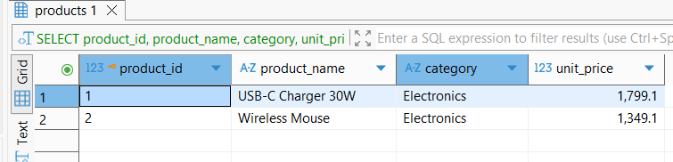

## 2. **`sp_cancel_order(p_order_id INT)`**     - Set order `status` to `cancelled` **only if** it is not already `delivered`.     - (Optional) Delete unpaid `payments` if any exist for that order (there shouldn’t be, but handle defensively).

**CREATE** **OR** **REPLACE** **PROCEDURE** training_ecom.sp_cancel_order(p_order_id **INT**)

**LANGUAGE** plpgsql **AS** **$$**

**BEGIN**

**UPDATE** training_ecom.orders

**SET** status = 'cancelled'

**WHERE** order_id = p_order_id

**AND** status != 'delivered';

**IF** **NOT** **FOUND** **THEN**

**RAISE** **NOTICE** 'Order % not found or already delivered.', p_order_id;

**END** **IF**;

-- Delete any unpaid payments (defensive, should not exist)

**DELETE** **FROM** training_ecom.payments

**WHERE** order_id = p_order_id

**AND** paid_at **IS** **NULL**;

**END**;

**$$**;

**CALL** training_ecom.sp_cancel_order(6);

**SELECT** order_id, customer_id, status

**FROM** training_ecom.orders

**WHERE** order_id = 6;

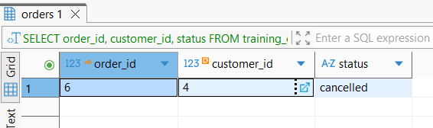

## 3. **`sp_reprice_stale_products(p_days INT, p_increase NUMERIC)`**     - For products **not ordered** in the last `p_days`, increase `unit_price` by `p_increase` percent.

**CREATE** **OR** **REPLACE** **PROCEDURE** training_ecom.sp_reprice_stale_products(p_days **INT**, p_increase **NUMERIC**)

**LANGUAGE** plpgsql **AS** **$$**

**BEGIN**

**UPDATE** training_ecom.products p

**SET** unit_price = unit_price * (1 + p_increase / 100)

**WHERE** **NOT** **EXISTS** (

**SELECT** 1

**FROM** training_ecom.order_items oi

**JOIN** training_ecom.orders o **ON** oi.order_id = o.order_id

**WHERE** oi.product_id = p.product_id

**AND** o.order_date >= CURRENT_DATE - **INTERVAL** '1 day' * p_days

)

**AND** p.active = **TRUE**;

**IF** **NOT** **FOUND** **THEN**

**RAISE** **NOTICE** 'No stale products found in the last % days.', p_days;

**END** **IF**;

**END**;

**$$**;

**CALL** training_ecom.sp_reprice_stale_products(30, 10);

**SELECT** product_id, product_name, unit_price, active

**FROM** training_ecom.products

**ORDER** **BY** product_id;

